Discovery Pathways Program

Medical Student Research Project

MSRP Contacts
Dr. Schultz, schultzg@ufl.edu 352.273.7560
Shawn Murphy smurphy21@ufl.edu 352.273.8580

International Medical Education Contacts
Dr. DeVos, Director, elizabeth.devos@jax.ufl.edu 352.273.6626
Dr. Grigg, Associate Director, james.grigg@medicine.ufl.edu. 352.273.6628

Website
The International Medical Education website is located at http://discovery.education.med.ufl.edu/. Our webpage has required training information and is a great resource for MSRP in general.

Canvas
A new Canvas website has been created will contain all the pertinent information for students travelling abroad for the project. Because it is an internal site, you will need to login with your GatorID.
https://ufl.instructure.com
Before leaving
Before buying tickets and planning your summer trip please be aware you are REQUIRED to have IRB-01 approval, approval from the appropriate agencies in the country you are visiting, and an affiliation agreement with the in-country research institution, school or other entity you will be working with to conduct your research.
Obtaining IRB-01 approval for international projects can take 6 months or more, so please plan accordingly and early.
Attend inter-professional pre-departure training workshop or complete Practitioner’s Guide to Global Health
https://www.edx.org/course/practitioners-guide-global-health-part-1-bux-globalhealthx-1
CISI Insurance Information
- All students are required to purchase CISI insurance through the UF International Center, unless they have GatorGradCare or GatorCare.
- $35/month per person, here is the enrollment form: https://www.ufic.ufl.edu/documents/CISI%20Enrollment%20Form.pdf
- Please feel free to contact Linda Gritman lgritma@ufic.ufl.edu or Yanping Cheng YCheng@ufic.ufl.edu with any questions pertaining to CISI insurance.
- All students will also have to complete the online travel registration. (ctrl + click to open hyper link to UFIC)

IMPORTANT: Please use the pdf below if you are unable to login to complete your travel registration.

University of Florida International Travel Check List
Please complete this form and send it to the person in your department responsible for travel before you travel abroad on behalf of the University of Florida. Please do so for each trip even if it involves repeated visits to the same country.
Traveling to (list countries): ____________________________________________________

__________________________________________________________________________

Travel dates: _______________ (mm/dd/yy) to ________________ (mm/dd/yy)
Travel dates: _______________ (mm/dd/yy) to ________________ (mm/dd/yy)
Travel dates: _______________ (mm/dd/yy) to ________________ (mm/dd/yy)
________ (initials) I have consulted with my clinician or a travel clinic about my international travel and have received necessary vaccines and travel medication

________ (initials) As required I have registered my international travel with the International Center (http://www.ufic.ufl.edu/travelregistration.html) and have received my TeamAssist card.

________ (initials or n/a) If I am traveling to an embargoed country, I have additionally read the UF policy at http://www.ufic.ufl.edu/TravelEmbargoed.html, and as required I have contacted Dean Leonardo Villalón.

Name: ________________________________________________
(exactly as it appears on your government-issued passport)
UFID ____________ Passport #: ______________
Date of passport issue:__________ (mm/dd/yy)
Date of passport expiration: __________ (mm/dd/yy)
Country of issue: ______________ Country of residence: ___________________

Signature: _________________________________ Date: _______________ (mm/dd/yy)

Team Assist Plan (a part of your CISI insurance)
For Team Assist Plan assistance, your ID number is your policy number. In the U.S., call (800) 472-0906, worldwide call collect (01-713) 267-2525 or e-mail customerservice3@aig.com ---part of your CISI insurance coverage, TAP includes:
Medical assistance
Medical Referral
Referrals will be provided for physicians, hospitals, clinics or any other medical service provider requested by the Insured. Service is available 24 hours a day, worldwide.

Medical Monitoring
In the event the Insured is admitted to a U.S. or foreign hospital, the AP will coordinate communication between the Insured’s own physician and the attending medical doctor or doctors. The AP will monitor the Insured’s progress and update the family or the insurance company accordingly.

Prescription Drug Replacement/Shipment
Assistance will be provided in replacing lost, misplaced, or forgotten medication by locating a supplier of the same medication or by arranging for shipment of the medication as soon as possible.

Emergency Message Transmittal
The AP will forward an emergency message to and from a family member, friend or medical provider.

Coverage Verification/ Payment Assistance for Medical Expenses
The AP will provide verification of the Insured’s medical insurance coverage when necessary to gain admittance to foreign hospitals, and if requested, and approved by the Insured’s insurance company, or with adequate credit guarantees as determined by the Insured, provide a guarantee of payment to the treating facility.

Travel assistance
Obtaining Emergency Cash
The AP will advise how to obtain or to send emergency funds world-wide.

Traveler Check Replacement Assistance
The AP will assist in obtaining replacements for lost or stolen traveler checks from any company, i.e., Visa, Master Card, Cooks, American Express, etc., worldwide.

Lost/ Delayed Luggage Tracing
The AP will assist the Insured whose baggage is lost, stolen or delayed while traveling on a common carrier. The AP will advise the Insured of the proper reporting procedures and will help travelers maintain contact with the appropriate companies or authorities to help resolve the problem.

Replacement of Lost or Stolen Airline Ticket
One telephone call to the provided 800 number will activate the AP’s staff in obtaining a replacement ticket.

Technical assistance
Credit Card/ Passport/ Important Document Replacement
The AP will assist in the replacement of any lost or stolen important document such as a credit
card, passport, visa, medical record, etc. and have the documents delivered or picked up at the nearest embassy or consulate.

Locating Legal Services
The AP will help the Insured contact a local attorney or the appropriate consular officer when an Insured is arrested or detained, is in an automobile accident, or otherwise needs legal help. The AP will maintain communications with the Insured, family, and business associates until legal counsel has been retained by or for the Insured.

Assistance in Posting Bond/ Bail
The AP will arrange for the bail bondsman to contact the Insured or to visit at the jail if incarcerated.

Worldwide Inoculation Information
Information will be provided if requested by an Insured for all required inoculations relative to the area of the world being visited as well as any other pertinent medical information.

Section III-Security Evacuation (Comprehensive)
Coverage (up to the amount shown in the Schedule of Benefits, Security Evacuation) is provided for security evacuations for specific Occurrences. To download a detailed PDF of this brochure, please go to the following web page: http://www.culturalinsurance.com/cisi_forms.asp

PASSPORTS and VISAS
Please check your destination country’s passport requirements. Each country can set their own regulations as to who many enter their country and under what circumstances. Please check the United States Government Passport website at:
http://travel.state.gov/content/passports/english/country.html
For this example I chose Ecuador, I then expanded the view on “Entry, exit and visa requirements” to find out more about the requirements Ecuador has for visitors.
Please be sure your destination does not require a visa, just because it wasn’t required last year doesn’t mean the situation is static. You can check the US Government Passport website by destination and verify information with your in-country hosts. Of importance, countries may restrict visas to citizens from foreign countries so if a visa is required please find out if your citizenship status is eligible for the visa by expanding the “Entry, exit and visa
requirements”.
Also, please check the website for rules pertaining to Green Cards. Green cards may be needed when visiting your host country, be sure to take the original with you as a copy will not suffice. Again check the host countries requirements on the government websites. Any green card holder must carefully review requirements for travel to the foreign country including requirements based on their green card status for travel and re-entry to the U.S. and also regulations for travel to the foreign site based on their country of origin. Get help interpreting the rules ASAP if you are unsure.

6 Months Validity Rule
The Six Months Validity Rule is imposed by foreign countries, and not by the United States. It simply means that your passport should be valid for more than six months before you would be allowed to enter a foreign destination.

PLEASE NOTE the list of countries that require a 6 month validity rule may change.
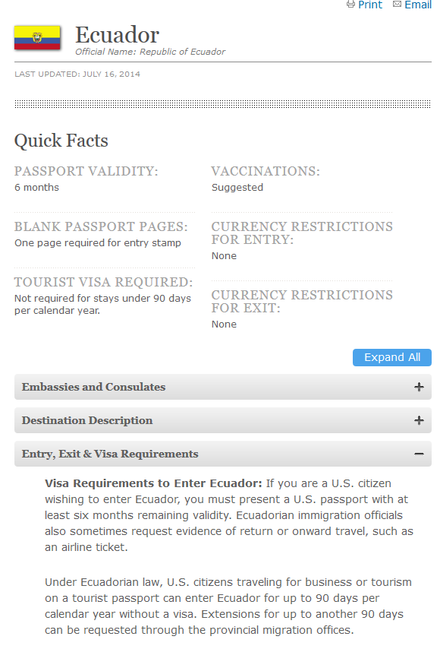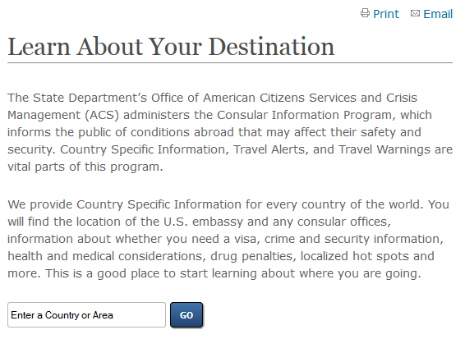

Travel Alerts and Warnings
Also, please check the US Government Passport website for the most updated information on travel alerts and warnings: Discuss project with UF mentor and complete MSRP proposal form -Review state department travel alerts and warnings for proposed destination https://travel.state.gov/content/passports/en/alertswarnings.html

Enroll in State Department Smart Traveler Program https://travel.state.gov/content/passports/en/go/step.html
Unexpected Circumstances

While we recommend students and faculty purchase traveler’s insurance, it is not required. Travel insurance may be able to help cover the expenses of unexpected circumstances such as sudden cancellations, accidental delays, missed flights or other unforeseen circumstances. In the event that you may experience a delay or unforeseen circumstance, some advanced planning may help. For example, having contact information for your lead faculty, trip leaders, in-country hosts, and the International Medical Education Office phone number.

To be better prepared for emergency situations while travelling you can reference this page:

http://www.state.gov/travel/

Contingency Plan
- If you can, buy travel insurance! This is the single best thing you can do to protect yourself financially if you miss your flight. Even if you tack on the travel insurance offered by the airline at the time of your individual airline ticket purchase.
- Keep copies of our insurance and contact information card with you. You can scan to a home email, keep a photocopy with your passport, and be sure that it includes your hotel information and personal medical needs.
- Be sure to have ready cash for emergency expenditures, this can be the accepted currency of your destination country, visa or master card.
- Read the passport and visa requirements for your destination on the US Government Passport website while you are planning you trip, as soon as you decide you will travel internationally, to be sure you have time to prepare for any passport or visa requirements that must be met: http://travel.state.gov/content/passports/english/country.html
- Familiarize yourself with emergency procedures and contact information on the Department of State website: http://www.state.gov/travel/
State-side
If you get separated from your group State-side call the trip leaders and lead faculty immediately, inform them of the situation. You may be able to re-group easily if you are simply in the wrong location with enough time to meet the group.
If you have missed the bus to the airport and still have time you may use an Enterprise Rental car to get to the airport. If there is an immediate availability you may still be able to rejoin the group but this is not guaranteed as with all rentals, it is dependent on availability.
Alternatively if you miss your flight for whatever reason but are still at the airport, please reserve an Enterprise Rental car and return to Campus. Call Shawn and she can reserve the rental car for you with her pcard. Your trips Foundation funds will then pay the pcard balance for the rental. Please note, any student that is using an Enterprise Rental car needs to be 21 years old or over.
Internationally
If you do not speak the language and are separated from the group and unable to regroup, seek uniformed officials only and ask for English speakers to help you.
If you miss a connecting flight in a foreign country or are separated from the group, again, call your trip leaders and lead faculty immediately. Try to re-group. If not, make your way to the terminal as best as you can, asking for assistance if necessary from uniformed airport employees. Try to contact the group to let them know you are on a later flight and be sure they can wait for you. If you will not be able to reconnect with the group take a flight back home.
If you are unable to switch your ticket or have travel issues, contact the US embassy in that country for assistance.

